**CO2-Based Geothermal EGS Off-Design Analysis**

*TUM-UNIFI Collaboration*

*Research Proposal*

*Pietro Ungar, Christopher Schifflechner*

**December 12th, 2022**

# Introduction

In literature, many researchers have analyzed the behavior of CO2-based geothermal systems for power, heat, or cogeneration purposes. On the other hand, no significant analysis has been developed on the off-design behavior of those systems. Nevertheless, two significant off-design effects can be identified:

1. **Effect of a change in ambient temperature**: in all the analyzed articles the ambient temperature has been considered as a fixed parameter. The study of the system's behavior for a change in ambient conditions on a daily and annual basis) is of interest.
2. **Effect of a change of production well conditions**: During the lifetime of the power plant reservoir condition can deteriorate leading to a decrease in production well outlet temperature, pressure, or flow rate. Again, it is interesting for the researcher to study how the system reacts to these changes.

In both cases, it can be of interest to study how the system must be controlled to maximize the power extraction of the system even in off-design conditions.

Of the two effects, it has been agreed that **in the first phase our study will focus on the ambient conditions variation** **effect** as it will be easier to collect meteorological data from different locations in the world, while reservoir condition variation in CO2-based geothermal systems is not well known yet. Moreover, changing ambient conditions are expected to have a greater impact on the system. The meteorological condition considered will be summarized in *paragraph 4.*

## System under scrutiny

The analysis will be focused on the direct expansion scheme for power generation as identified in *figure 1*. The system is composed of a turbine, a gas cooler, and a pump. An off-design model should be identified for each component together with a control strategy for the system. A detailed description of these aspects will be provided in *paragraphs 2 and 3*.

### Reservoir Model

In *figure 1* both EGS and BHE systems are shown as they will react differently to a change in ambient conditions.

The pressure inside the **EGS reservoir** is almost fixed by the geological condition hence a change in the injection density **will likely affect the flow rate circulating in the system** (because of a variation in the gravitational pressure increase) while only slightly affecting the turbine pressure inlet due to pressure losses in production well. On the other hand, in **BHE systems**, a variation in input condition will mainly result in **a variation in the outlet pressure**.

As both systems have already been modeled in the python code developed by UNIFI they can be easily integrated into the study once the off-design model of the surface plant has been developed. *Please note that the EGS model developed by UNIFI is just the python translation of the model developed by TUM in MATLAB.*

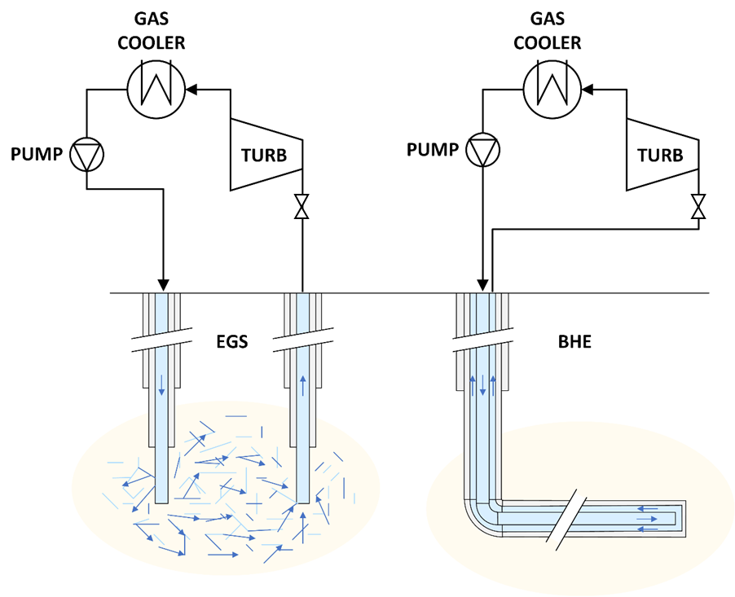

**Figure 1:** *Simplified system representation for both EGS and BHE systems.*

# Components Off-Design Model

## Turbine

The turbine off-design model has the highest impact on the system behavior. The off-design behavior of the turbine is based on two characteristic curves:

### Stodola Curve

The Stodola curve [1] determines the relation between the pressure ratio and the reduced flow rate for each turbine stage. The relation is defined as follows:

|  |  |
| --- | --- |
| $$β_{i}= \frac{1}{\sqrt{1-{Φ_{i}}^{2}Y_{id}}}$$ | (1) |

Where the subscript $i$ refers to the ith stage of the turbine, $β$ is the pressure ratio $Y_{id}$ is a design parameter and $Φ$ is the flow coefficient defined as follows:

|  |  |
| --- | --- |
| $$Φ_{i}= \frac{{\dot{m}}_{i}}{\sqrt{p_{i}ρ_{i}}}$$ | (2) |

Pressure and density from the formula above refer to the inlet condition of the stage. For this reason, *eq. 1* is explicit only if the calculation proceeds from the inlet to the outlet of the turbine. Unfortunately, the discharge pressure of the turbine is usually known, while the inlet pressure can be adjusted through a lamination process. In these cases, an iterative procedure is required.

For multistage turbines, the pressure ratio of a single stage can be evaluated using the Stodola curve starting from the gas generator condition. The overall pressure ratio can be then identified by multiplying each stage's result. This will require setting a design parameter for each stage.

### Variable Geometry

What just said is not valid for turbines with adjustable geometry (*such as NGVs)*. In those cases, *eq. 1* should be discarded following the suggestion contained in Manente et Al. [2], considering the flow rate to be adjustable according to the need regardless of the pressure drop on the turbine.

Variable geometry turbines are more complex and unreliable due to the increase in moving parts. Moreover, it is still unclear if is possible to implement such a mechanism given the high-pressure environment in which the turbine will operate or if a variable geometry expander for sCO2 is available on the market. Variable geometry turbines are usually more expensive than standard ones hence it should be investigated the existence of a cost correlation capable of identifying such cost increase to perform a cost-benefit analysis.

### Efficiency Curve

Following the suggestion of Prof. Manfrida [3], the off-design efficiency of the turbine can be calculated using the correlation proposed by Latimer.

|  |  |
| --- | --- |
| $$\log_{10}\left({η_{i}}/{{η_{des}}_{i}}\right)= -0,0817*x^{3}-0,3181*x^{2}+0,0019*x$$ | (3) |

Where:

|  |  |
| --- | --- |
| $$x=\log_{10}\left({{{Δh}_{st}}_{i}}/{{{{Δh}_{st}}_{des}}_{i}}\right)$$ | (4) |

${Δh}_{st}$ is the enthalpy drop over the stage *(isentropic enthalpy drop can be used without major error to make the efficiency calculation explicit)*. The design efficiency for each stage ${η_{des}}_{i}$ is usually considered to be 0.7.

### Fixing the design parameters

For what just said the off-design behavior can be described using *eq. 1* and *eq. 3* which require the identification of one design parameter each for each stage, as summarized in the table below:

|  |  |  |
| --- | --- | --- |
| **Equation** | **Parameters** | **Description** |
| $$β_{i}= \frac{1}{\sqrt{1-{Φ_{i}}^{2}Y_{id}}}$$ | $$Y_{id}$$ | *Relation between pressure drop and flow rate* |
| $${η_{i}}/{{η_{des}}_{i}}= f({{{Δh}_{st}}_{i}}/{{{{Δh}_{st}}_{des}}_{i}})$$ | $${{{Δh}_{st}}_{des}}_{i}$$ | *Efficiency curve (eq. 3)* |

To set up these parameters the *design condition* of the system must be identified *(desired power output of the turbine given a specific ambient temperature).* Once the design thermodynamics of the system has been solved, the turbine must be discretized in a defined number of stages. Usually, stages are designed to have a common ${{{Δh}_{st}}_{des}}_{i}$ as shown in *figure 2.a*. For that reason:

|  |  |
| --- | --- |
| $${{{Δh}_{st}}_{des}}_{i}={{{Δh}_{st}}_{des}}/n$$ | (5) |

Where $n$ is the number of stages. $β_{des}$ can be then calculated for each stage given the output enthalpy allowing for the calculation of $Y_{id}$ by simply reversing *eq. 1.*

In selecting the design point, please consider the maximum value of $Φ_{i}$ is set by the design condition (this reflects the fact that at some point the flow in the turbine will be chocked allowing no further increase in the flow rate). This is especially critical for stages with $β_{des}>1.6$ for which the $Φ_{des}$ is already very close to the limit condition (see *figure 2.b)*, meaning that the flow rate in the turbine cannot be greater than the one specified at the design condition. For this reason, choosing a design point with a small flow rate can lead to inefficient off-design behavior (as the flow rate cannot be further increased).

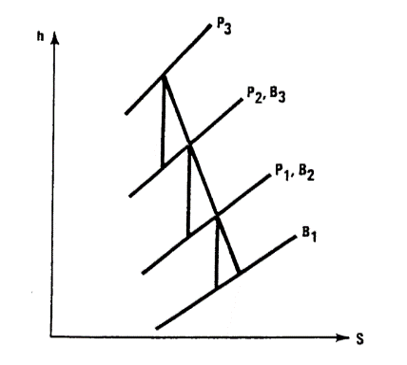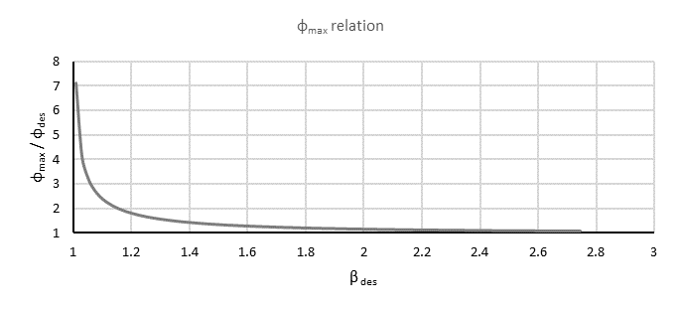

**a)**

**b)**

**Figure 2:** *a) Schematics of a turbine stage definition* [1]*, b) relation between $Φ_{max}$ and $β_{des}$*

## Gas Cooler

For the gas cooler, two different designs should be considered:

1. **Air coolers**
2. **Water circuit coupled with cooling tower**

The second design is expected to allow for lower well inlet temperatures, especially in dry climates, but has the downside of increased system complexity.

Given the ease with which these systems can be controlled, a detailed off-design model is usually not necessary as in the real world their complexity is hidden by the behavior of the control system.

For this reason, initially the off-design behavior of the heat exchanger can be simply modelled considering a **fixed approach temperature** between the cooling fluid and the CO2:

|  |  |
| --- | --- |
|  | (6) |

Where $T_{cool in}$ and ${∆T}_{appr}$ will be defined differently depending on the cooling design as summarized in the table below:

|  |  |  |
| --- | --- | --- |
| **Cooling Design** | $$T_{cool in}$$ | $${∆T}_{appr}$$ |
| *Air Coolers* | Ambient Temperature | 10°C |
| *Cooling Tower* | Wet-bulb Temperature | 5°C |

The difference in ${∆T}_{appr}$ is justified by the fact that water-based heat exchangers are usually more efficient that air-based ones.

## Pump

Pumping is not requested in some schemes found in the literature that relies on natural circulation only. We decided to implement it as it can be useful in the control of the off-design operation. Some characteristic curves for pumps are presented in Manente et Al. [2]. These curves can be rescaled according to our needs considering the percentual variation of the parameters to predict the reasonable behavior of pumps with different geometry.

# System Control

Different control mechanisms should be considered depending on if the geothermal system is EGS or BHE based and if the turbine has a variable geometry

* For **EGS-based models with fixed geometry,** the pressure at the gas cooler must be optimized to maximize the power output of the turbine. Once the pressure at the gas cooler has been set the flow rate is defined by the turbine hence pump power should be selected to match the inlet pressure required by the EGS system for injecting that specific flow rate.
* For **EGS-based models with variable geometry,** againthe pressure at the gas cooler should be optimized. Due to the variable geometry of the turbine, the flow rate is no longer defined for a given gas cooler pressure and it can be controlled by varying the pump power. For his reason, pump power should be optimized for each condition to maximize the power output.
* For **BHE-based models with fixed geometry,** in this case, BHE input and output conditions are related. Both gas cooler and BHE input pressures must be optimized, the flow rate is then defined through the turbine curve
* For **BHE-based models with variable geometry,** Gas cooler and BHE input pressures must be optimized together with flow rate to maximize power output (in real operation flow rate is controlled by varying the opening of the turbine IGVs)

# Meteorological Data

Both daily and annual meteorological data are needed for the off-design evaluation. The data needed are the ambient temperature and the relative humidity (for cooling tower output temperature calculation)

It has been agreed that four different scenarios might be analyzed given the temperature and the environmental humidity.

|  |  |  |  |
| --- | --- | --- | --- |
|  | | *Avg. Relative humidity* | |
| **Dry (<60%)** | **Humid (>80%)** |
| *Avg. Temperature* | **Low** | Cheyenne (*Wyoming*) | Munich |
| **High** | Riyadh (*Saudi Arabia*) | Florence |

The meteorological data has been downloaded from the ERA5 database using the [Open-Meteo Historical Weather API](https://open-meteo.com/en/docs/historical-weather-api). Please note that ERA5 data are not direct measurement recordings but are the result of complex meteorological calculations based on real measurements.

# Final Remarks

## Correctness of the Quasi-static model

For a *quasi-static* model to be correct the dynamics of the system are supposed to be much faster than the variation of environmental conditions. This hypothesis is surely verified for seasonal variation while it can be problematic for daily variation, especially of EGS systems (according to some production experiments for water-based systems, transient up to 3 hours are expected for the system startup). System dynamics should be studied to assess the correctness of the quasi-static hypothesis.

## Economic model

A detailed economic evaluation is needed to complete the study. The economic analysis is not present in this document, but it should be implemented before a publication is proposed. Depending on the remaining time until the expected end of her master thesis once the other calculation has been performed, the economic analysis can be performed either by Shaila, by Pietro, or by another master student.

Many correlations can be found in the literature for both components and reservoir development costs. Anyway, some questions are still open such as the increase in cost for variable geometry expanders.

# References

[1] *Cooke, D. H. (1985)*. On Prediction of Off-Design Multistage Turbine Pressures by Stodola’s Ellipse. *Journal of Engineering for Gas Turbines and Power, 107* (3), 596–606. https://doi.org/10.1115/1.3239778

[2] *Manente, G., Toffolo, A., Lazzaretto, A.; Paci, M. (2013).* An Organic Rankine Cycle off-design model for the search of the optimal control strategy. *Energy, 58*, 97–106. https://doi.org/10.1016/j.energy.2012.12.035

[3] *Fiaschi, D., Manfrida, G., & Talluri, L. (2015). Integrated model of a solar chimney Equipped with axial turbines. ECOS 2015 - THE 28TH INTERNATIONAL CONFERENCE ON EFFICIENCY, COST, OPTIMIZATION, SIMULATION AND ENVIRONMENTAL IMPACT OF ENERGY SYSTEMS.*

# Annex - Workplan

Attached is the workplan as currently defined, the updated version can be found [here](https://unifiit0-my.sharepoint.com/:x:/g/personal/pietro_ungar_unifi_it/EQV7Knx0fhxLjHH65ENdbwYBfWaNNEZ9VxY2csJCQw2N_w).

The plan has been drafted to finish on the 1st of march in line with the expected Shaila graduation date

